**Quiz Manager Application**

**User Guide**

The following document is to instruct the user (you) on how to access and use the Quiz Management system.

The system is designed with three different access roles available. These are Restricted, View and Edit.

Restricted users can only view the quizzes and their corresponding questions. Users with the View permission can access all of the above quizzes, their corresponding questions and also the answers associated with each question. The final permission is Edit. These users can do all of the above, but have the capability to add/delete new quizzes and amend the questions and answers within the quizzes.

Contents

Logging In: 2

Select a Quiz Screen: 3

Quiz Details Screen: 4

View/Hide Quiz: 5

Select a Quiz Screen: 7

Create/Update a Quiz Screen: 8

**User – All Users**

# **Logging In:**

Upon starting the application, you will be presented with a login screen. Enter the username and password you have been provided as an editor, viewer or restricted user, into the corresponding input fields and click the Sign In button.

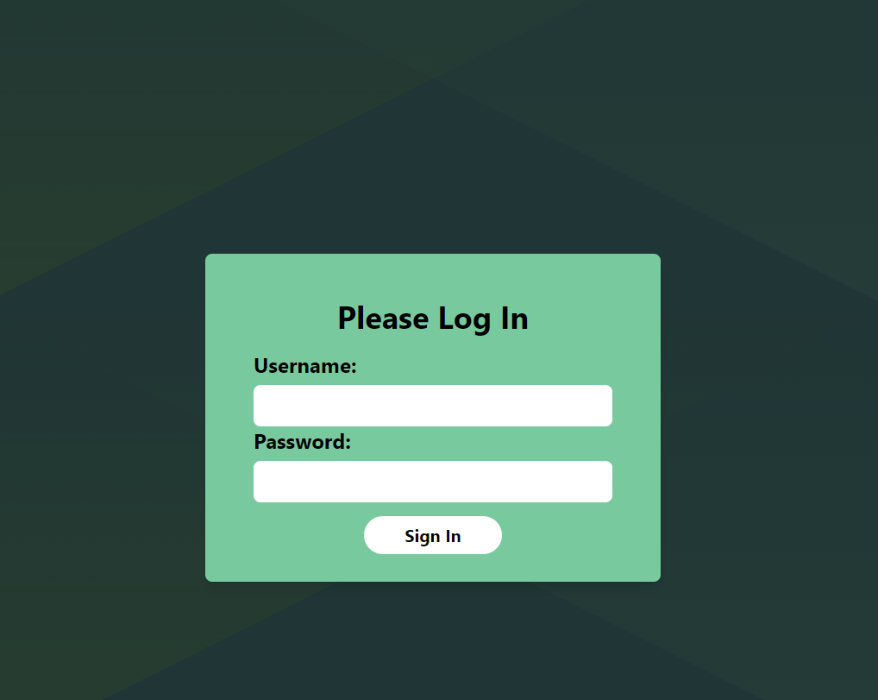

# **Select a Quiz Screen:**

Once logged in, you will be presented with a series of available quizzes that are present in the system.

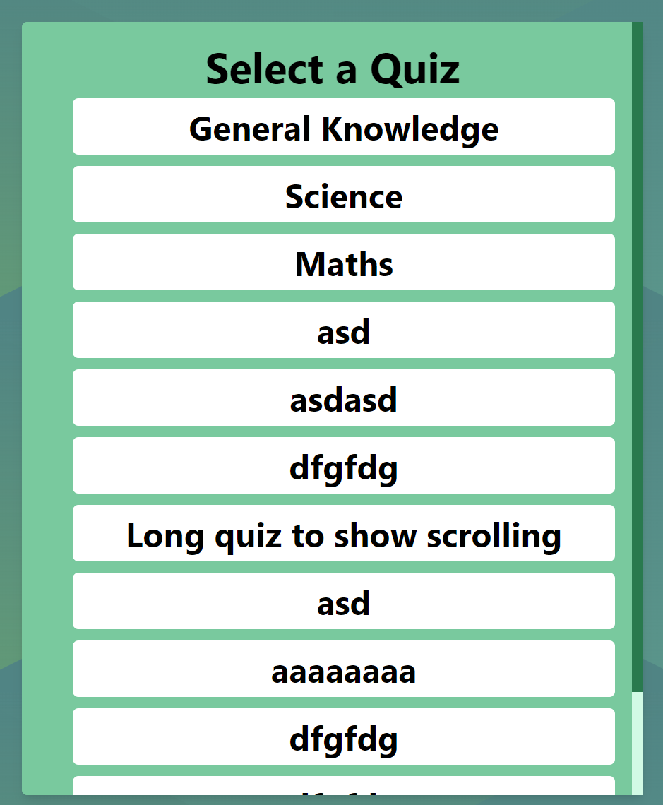

If there are more quizzes than can fit on the screen, a scrollbar will appear to the right as shown in the above image.

Below the quiz list is a logout button. This will log you out from the system and return you to the login screen as shown in the first section of the document.



To view the content of a quiz, you must click the white container or title of the quiz you wish to view. Doing so will present you with the quiz details screen.

# **Quiz Details Screen:**

On the quiz details screen, you will be presented with all of the questions available to that quiz. As a restricted user, you will only be able to view the quiz and question titles, as well as the question number.

The close button will return you to the Select a Quiz screen.

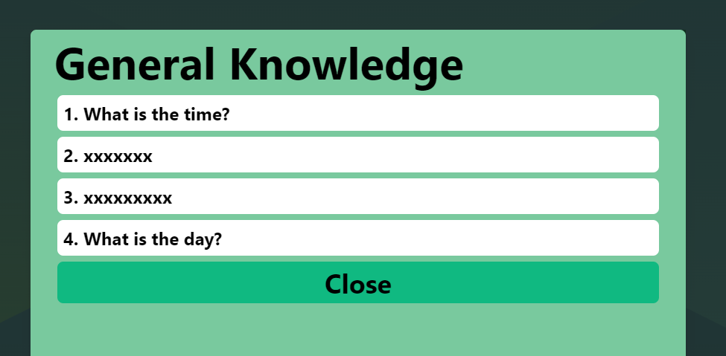

**User – Logged in With View Role**

# **View/Hide Quiz:**

As a user with the View access role, you will be able to access all of the functionality previously explained above.

In addition to this, you will also be able to view the answers to each question of a quiz.

To do this, you must access the quiz details screen.

From here you will see a show/hide eye icon at the top right of the box, alongside the title. Clicking this will show/hide all of the questions associated to the particular quiz you are viewing.

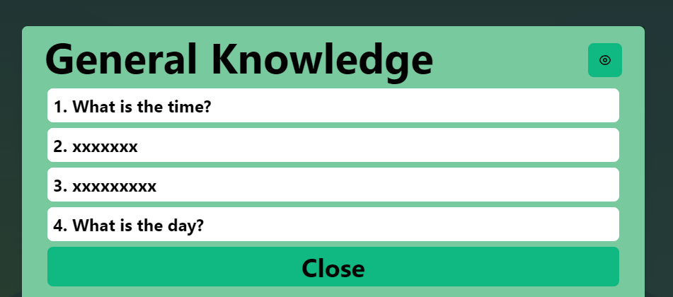

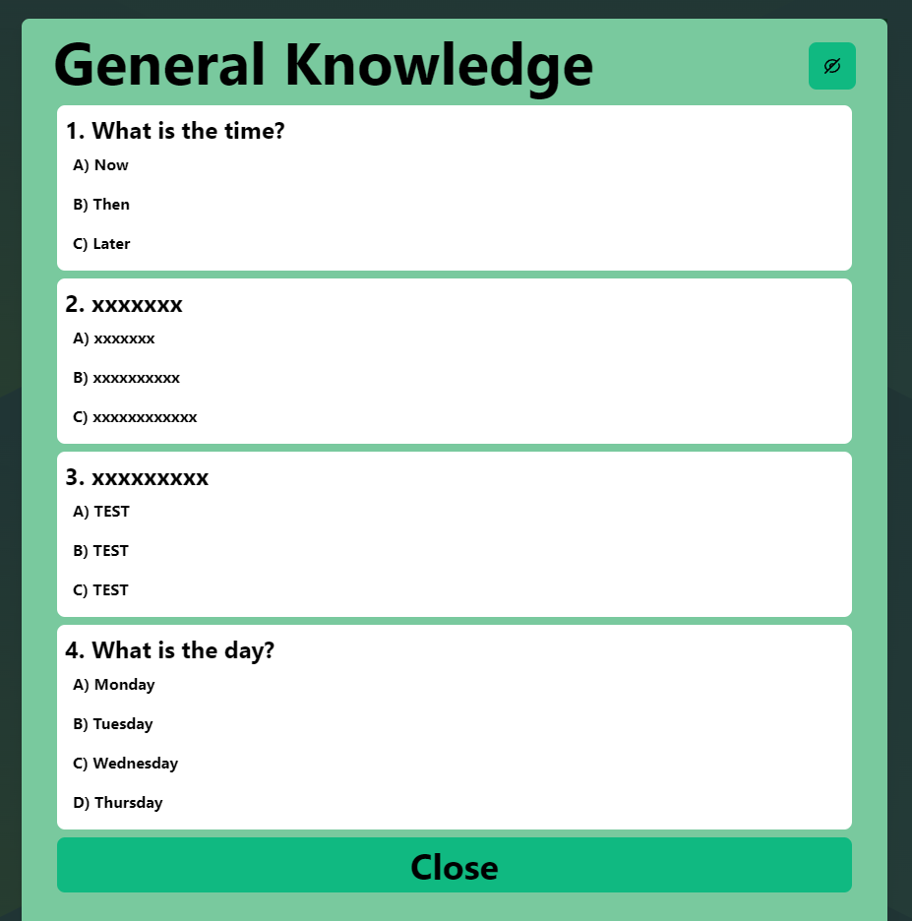

**User – Logged in With Edit Role**

As a user with Edit permissions, you will be able to carry out all of the actions as outlined above in the previous sections of the document.

# **Select a Quiz Screen:**

Upon logging in, you will be presented with a list of all the available quizzes as with the other two access roles. However, you will now see that there are icons to the right of each quiz title. This icon represents a bin, and clicking this will delete a quiz from the list and in turn, deletes the quiz from the database.

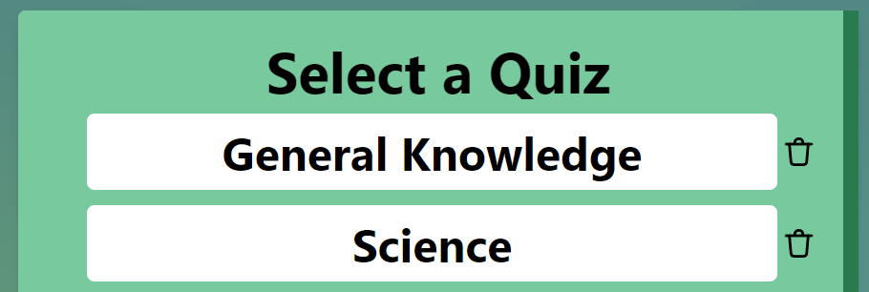

In addition, towards the bottom of the page you will now see that there is an Add New Quiz button. Clicking this will present you with a new screen, where you can add questions and create a new quiz.

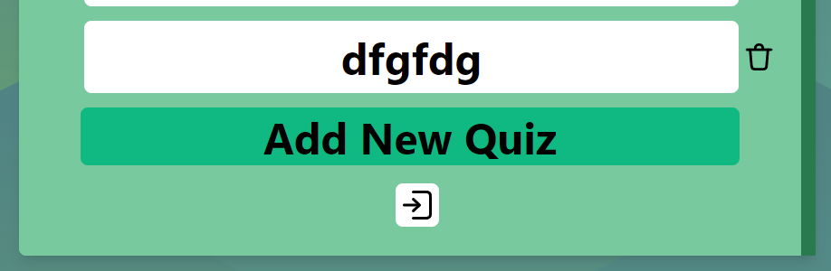

One the Create/Update a Quiz screen loads, you will be required to input a title for the quiz. If you attempt to submit the quiz without doing so, an error will be displayed.

# **Create/Update a Quiz Screen:**

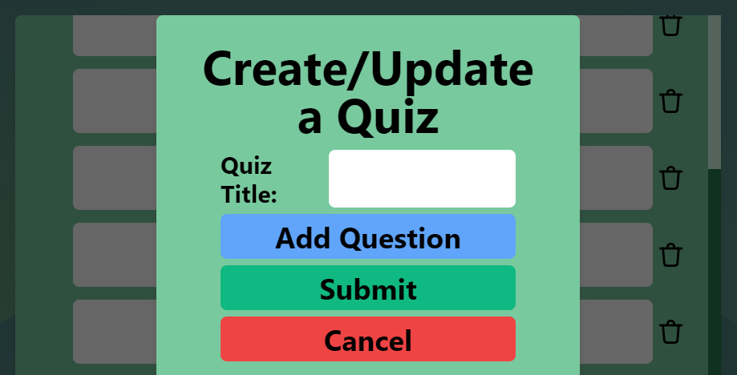

Also on this page are several buttons. The Submit button will add your new quiz to the database and update the list of quizzes on the website.

The Cancel button will return you to the Select a Quiz screen without saving any changes you may have made.

In addition, there is an Add Question button. Clicking this will present you with a new screen, where you can add a new question and the associated answers. You can click this button multiple times, to add multiple questions to the quiz.

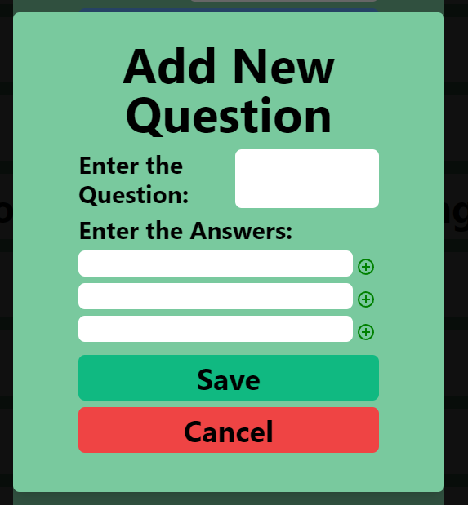

You are required to enter a question in the ‘Enter a Question’ field. If you try to save without entering a question, it will display an error on the screen.

You are required to enter a minimum of three questions, up to a maximum of five. This can be done by clicking the + icon to the right of an answer field.

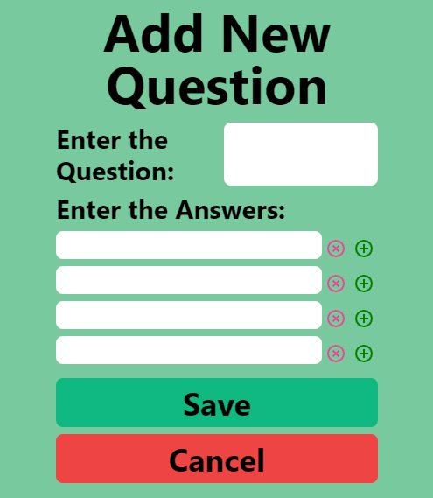

If you wish to remove an answer, you can also click the X icon and this will remove the corresponding answer from the list.

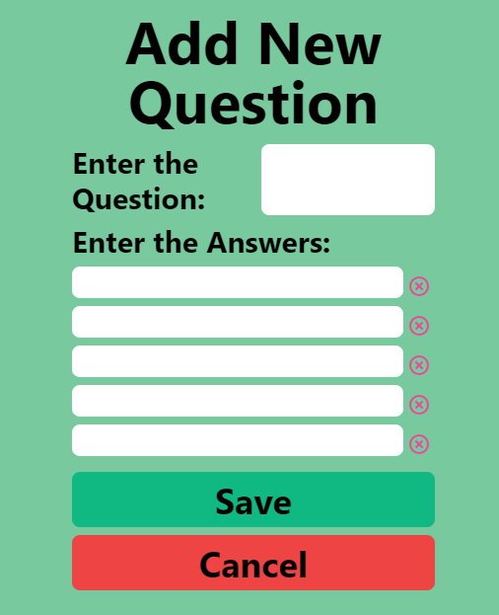

As you can see, once five answers have been added it will not allow you to enter any more.

Clicking the Save button will add this question and answers to the quiz, clicking the Cancel button will return you to the Create/Update a Quiz screen.

**Editing a Quiz:**

To edit a quiz, you must go to the quiz details screen of the quiz you wish to update.

From here, you will now see a new icon displayed at the top right.

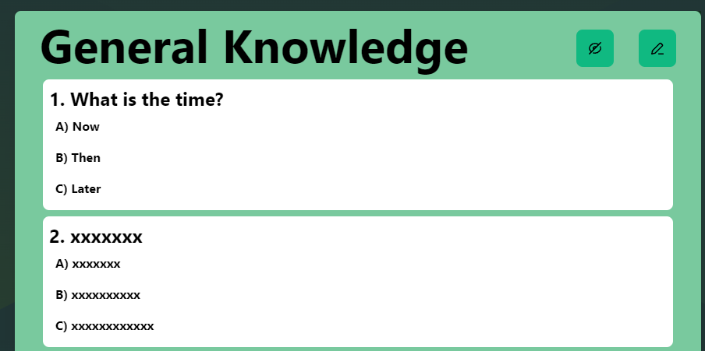

This pencil icon is used to present the edit quiz screen and will display a new window when clicked.

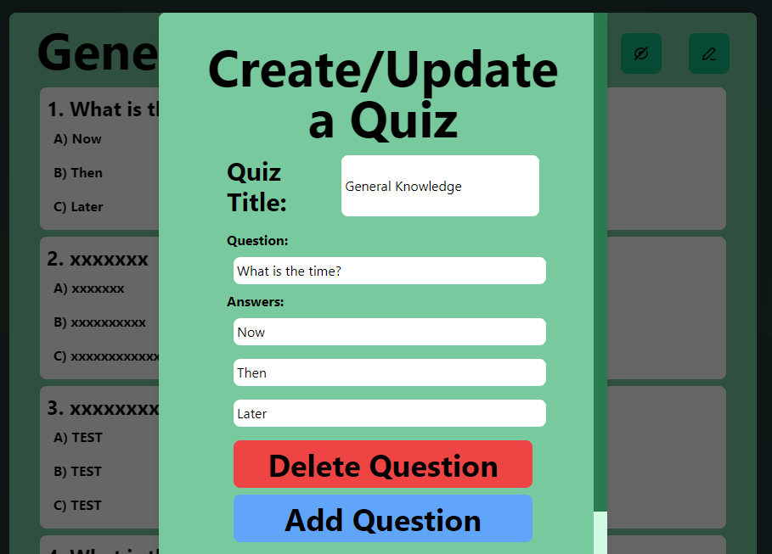

As you can see from the image above, the fields are now auto-populated with the details of the specific quiz you chose.

This screen operates in the same manner as explained in the create a new quiz section. You have the capability to add questions using the Add Question button, which will then bring up the add question screen as outlined previously. The Delete Question button will allow you to delete questions from the quiz.

Once you have made your required changes, you will need to click the Submit button at the bottom of the screen, which will send your changes to the database and update the quiz list accordingly.

